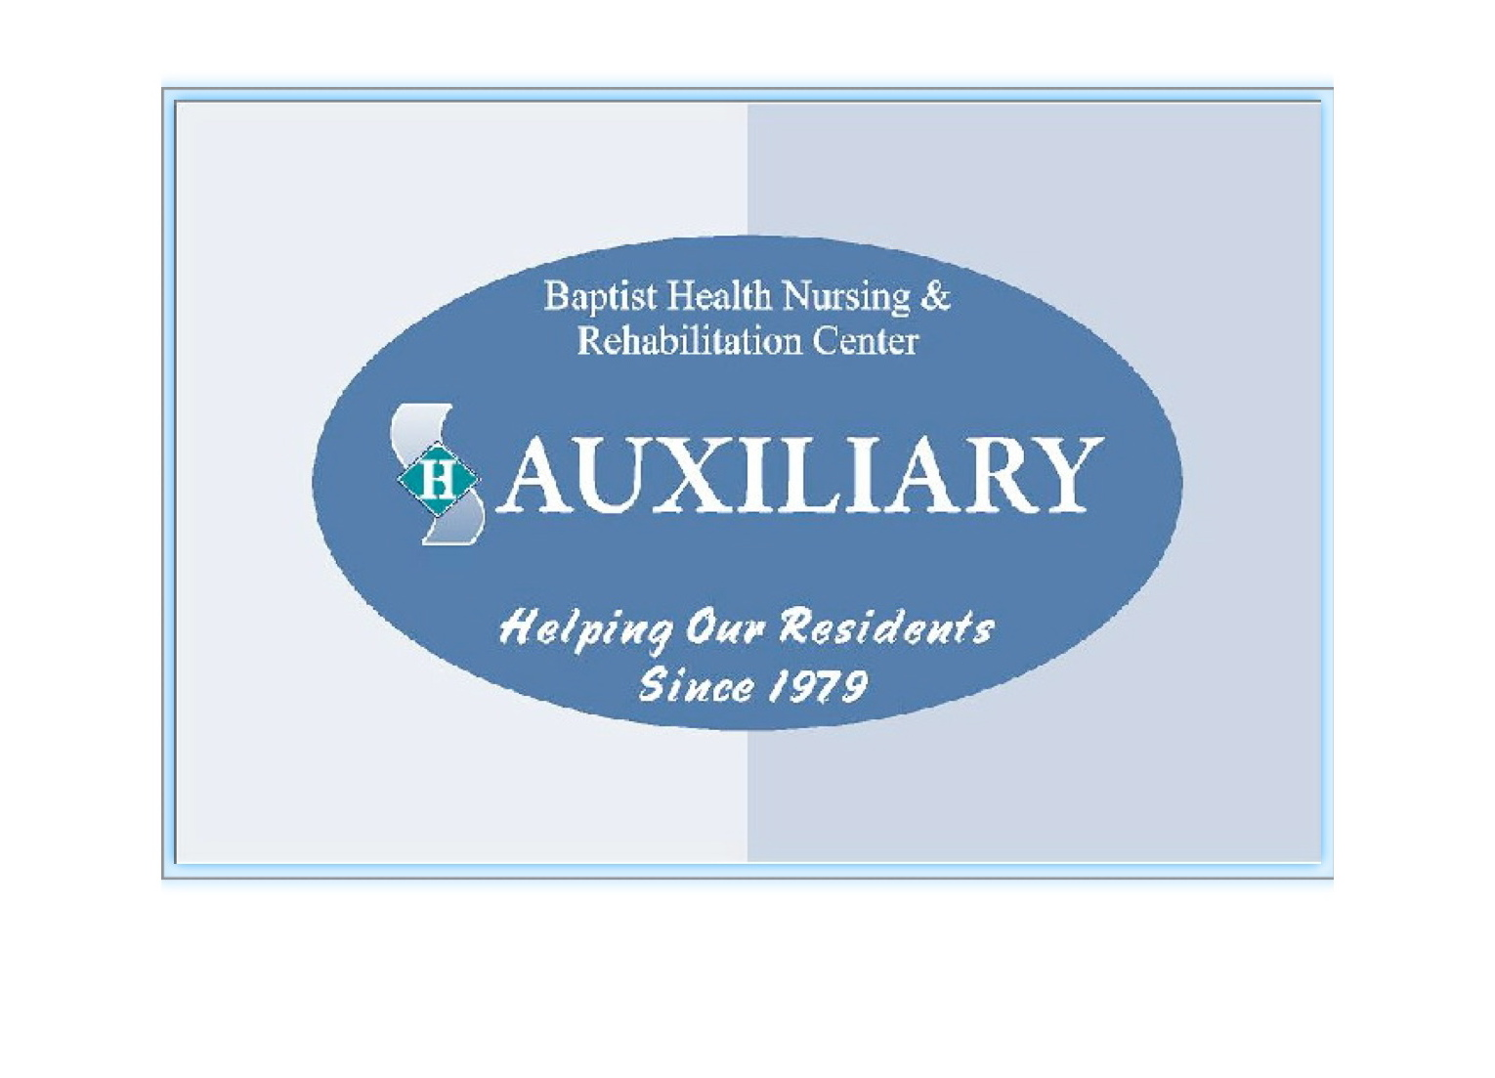
_______________________________________________________________

BAPTIST HEALTH NURSING & REHABILITATION CENTER

AUXILIARY MEMBERSHIP APPLICATION

Name ____________________________________ DOB ___________ (m/d)

Address _________________________________________________________

_________________________________________________________

Home phone # _________________ Cell # _________________________

Please check one:

New membership ___________ Membership Renewal ______________

Active Membership _________

(I will try to attend meetings held at BHNRC the 2nd Monday of each month, 1PM)

Inactive Membership _________

(I would like to financially support the Auxiliary with my membership fee and take part in fundraisers when possible but will be unable to attend the monthly meetings)

The yearly membership fee is $10.00. Please make checks payable to BHNRC Auxiliary and send with this form to:

Anita Parker
c/o Baptist Health Nursing & Rehabilitation Center
297 N. Ballston Avenue
Scotia, NY 12302

